**Software Requirements**

**Specification**

**for**

**SMART HEALTH**

**Website**

**Version 3.0 approved**

**Prepared by**

**KHUSHI (2100290129005)**

**CHHAYANK TYAGI (2000290120059)**

**HANU AGARWAL (2000290120067)**

**KIET Group of Institutions**

**30th April,2023**

**TABLE OF CONTENTS**

1. **Introduction**
   1. Purpose 1
   2. Document Conventions  1
   3. Intended audience and reading suggestion… 1
   4. Product scope 2
   5. References 2
2. Overall descriptions
   1. Product Perspective 3
   2. Product Function 3
   3. User Classes and Characteristics 3
   4. Operating Environment 4
   5. Design and Implementation Constraints 4
   6. User Documentation 4
   7. Assumptions and Dependencies
3. External Interface Requirements

3.1 User interfaces 5

* 1. Hardware interfaces 7

1. System Features

4.1 System feature 1 8

1. Other Non-Functional Requirements

5.1 performance Requirements 9

5.2 Safety Requirements 9

5.3 Security Requirements 10

5.4 Software Quality Attributes 10

**Appendix A: Glossary** 11

**Appendix B: Analysis Models** 12

**Appendix C: To Be Determined List** 12

# Revision History

|  |  |  |  |
| --- | --- | --- | --- |
| **Name** | **Date** | **Reason For Changes** | **Version** |
| Appendix B | 01-05-2023 | Incorporate all the diagrams in Appendix B | 2.0 |
| Appendix A | 02-05-2023 | Incorporate Glossary along with many more changes | 3.0 |

**1. Introduction**

**1.1 Purpose**

The Smart Healthcare website which aims to solve many problem of patients and doctors i.e it provides the facility of saving the medical reports online. Sometimes when patients changes their doctors, then some of patients lost their prescriptions and are unable to tell doctors about their previous health issues so they can save all of their reports and documents on the platform for their better cure. The platform is also helpful for doctor as doctor can save all their patients history in efficient manner. Doctors can also refer prescriptions of other doctor for betterment.

**1.2 Document Conventions**

The document is prepared using Microsoft Word. The fixed font size that has been used to type this document is 12 pt with 1.5 linespacing along with 14pt for sub headings and 18 for main headings. It has used the bold property to set the headings of the document. All pages except the cover page are numbered, the numbers appear on the bottom of the page. Standard IEEE template is the template used to organize the appearance of the document and its flow.

**1.2 Intended Audience and Reading Suggestions**

**Intended Audience –**

**Developers:** This document will be primarily used by the development team to understand the functional and non-functional requirements of the Smart Care WebApp.

**Project Managers:** This document will be used by the project managers to plan and monitor the project's progress and ensure that the requirements are met.

**Testers:** This document will be used by the testing team to develop test cases and ensure that the system meets the specified requirements.

**Documentation Writers:** This document will be used by the documentation team to create user manuals and other instructional materials.

**Reading Suggestions –**

For an overview of the system's purpose and scope, start with the Introduction section. For a detailed description of the system's functional requirements, refer to the Functional Requirements section.

For a description of the system's non-functional requirements, refer to the Non-functional Requirements section.

For a description of the system's design and architecture, refer to the Design section. For a description of the system's testing approach and methodology, refer to the Testing section.

For a list of known issues and limitations, refer to the Bugs section.

It is recommended that readers start with the overview sections and then proceed to the sections that are most pertinent to their role or interest. Developers should focus on the functional and non-functional requirements, while testers should focus on the testing section. Project managers should review the entire document to ensure that the project is on track and that all requirements are met.

**1.3 Product Scope**

The Smart Care- Health based web-app has a wide scope in the upcoming world as smart health have gained significant attention in recent years as an innovative approach to healthcare. This system helps medical professionals in making accurate and timely diagnoses, as well as provide the correct treatment based on patient data. Connecting patients and doctors through a user-friendly interface will make it easier for patients to use in emergency situations. Integrating many platforms under one roof, such that blood availability, medicine availability, path-Labs services and also provide the storage of documents.

**1.4 References**

* <mailto:http://groups.umd.umich.edu/cis/course.des/cis375/active/class7/EM-SRS-ReviewSoftRightHospitalManagementSystemSRS.pdf>
* [mailto:1. Simon de Lusignan , Freda Mold, Aziz sheikh…(2013)Patients’ online access to their electronic health records and linked online services: a systematic interpretative review.](mailto:1.%09Simon%20de%20Lusignan%20,%20Freda%20Mold,%20Aziz%20sheikh…(2013)Patients’%20online%20access%20to%20their%20electronic%20health%20records%20and%20linked%20online%20services:%20a%20systematic%20interpretative%20review.)
* [mailto:2. Mandl KD, Szolovits P, Kohane IS-Public standards and patients’ control:](mailto:2.%09%20Mandl%20KD,%20Szolovits%20P,%20Kohane%20IS-Public%20standards%20and%20patients’%20control:)
* [mailto:Hassol A, Walker JM, Kidder D, -Patient experiences and attitudes about access to a patient electronic health care record and linked web messaging. J Am Med Inform Assoc (2004)](mailto:Hassol%20A,%20Walker%20JM,%20Kidder%20D,%20-Patient%20experiences%20and%20attitudes%20about%20access%20to%20a%20patient%20electronic%20health%20care%20record%20and%20linked%20web%20messaging.%20J%20Am%20Med%20Inform%20Assoc%20(2004))

**2. Overall Description**

**2.1 Product Perspective**

The product perspective of a Smart Health website involves defining how the websites fits into the larger ecosystem of health & wellness tools & services.

This health application will help the consumer to an easier and more eﬃcient way to live a healthier life. The main features of the software application include:

* Suggestion of specialised doctors
* Schedule an appointment for online consultation.
* The admin schedules a time for the patient for online consultation with the selected doctor.

**2.2 Product Functions**

A brief of the major product functions & what the end user may perform on the application include:

* Patient account and profile creation
* The application allows end users to create an account for themselves and manage personal information in their profile.
* Allows to store the patients past records.
* Search doctors
* Patients can search for doctors from their locality who can treat their disease.
* Get access to contact information of the doctors
* Book an appointment for online consultation

**2.3 User Classes and Characteristics**

Smart Care is intended for two types of users:

**For Patient :** Patients are the primary users of the website. They can login and store their records on single platform and it also contains a separate option for assigning or choosing the new doctor by the user end only .

**For Doctor :** They would be provided with patient reports and consultation time.

To ensure the website meets the needs of all users, it is essential to consider the characteristics of each user class during the design and development phrases of the object.

**2.4 Operating Environment**

**Hardware Platform:** The Smart Care WebApp will operate on any device with a modern web browser and an internet connection, including desktop computers, laptops, tablets, and mobile phones. The minimum required specifications for the hardware platform are a modern processor and at least 4GB of RAM.

**Operating System:** The Smart Care WebApp will be compatible with the major operating system, including Windows. The minimum required operating system version is Windows 7. Web Browser: The Smart Care WebApp will be accessible via any modern web browser, including Google Chrome, Mozilla Firefox, Apple Safari, and Microsoft Edge. The minimum required browser version is the latest stable release.

**Other Software Components:** The Smart Care WebApp will depend on several open-source software components, including Html, CSS, JavaScript, API’s ,Spring MVC, Spring Security, Spring JDBC and Spring Boot. These components will be integrated into the web application to provide the necessary functionality and user interface. It is important to note that the operating environment described above is subject to change based on the needs of the project and the evolving requirements of the web application. It is recommended that the development team regularly review and update the operating environment to ensure that the software remains compatible with the latest technologies and platforms.

**2.5 Design and Implementation Constraints**

**Technology Stack:** The development team has been instructed to use Html, CSS, JavaScript, API’s and Spring Boot for the development of the Smart Care WebApp.

**Security:** The web application must follow industry-standard security practices, including encryption of user data, protection against SQL injection attacks, and secure storage of user passwords by using Spring Security.

**Performance:** The web application must be responsive and provide real-time data updates. The development team must optimize the code and minimize the number of requests to the server to ensure smooth performance.

**Browser Compatibility:** The web application must be compatible with all modern web browsers, including Google Chrome, Mozilla Firefox, Apple Safari, and Microsoft Edge.

**User Interface Design:** The web application must follow a consistent user interface design.The design must be visually appealing and easy to use.

**Database:** The web application will use a MySQL database for storing user data and transaction history.

**Maintenance:** The development team will be responsible for maintaining the web application after deployment, including bug fixes, security updates, and feature enhancements. It is important to note that the design and implementation constraints described above may change over the course of the project as new requirements and limitations are identified. The development team should regularly review and update the constraints to ensure that the web application remains compliant with the latest industry standards and best practices.

**2.6 User Documentation**

A “Help” page will be available on the website providing explanations to all processes. As this application product is being designed which is clean, simple and easy to use, ideally, the website will require no additional explanation or support.

It also contain FAQ. An FAQ section can be a valuable resource for users who have questions about the website. It should cover common questions and issues that users may encounter, and provide clear and concise answers.

**2.7 Assumptions and Dependencies**

Assumptions: The availability of external APIs: The application may rely on external APIs to perform certain functions. Assumption is that these APIs will be available and reliable. The availability of the necessary infrastructure: The application will require a stable and secure infrastructure, including servers, storage, and networking equipment. Assumption is that these resources will be available and sufficient to support the application's needs. Dependencies: Web browser compatibility: The application is designed to work on modern web browsers such as Google Chrome, Mozilla Firefox, and Microsoft Edge, and may not function properly on older or less common web browsers. Internet connectivity: The application requires a stable and reliable internet connection for users to access and use the application. Security considerations: The application must adhere to security best practices and may rely on various security technologies and services, such as encryption and authentication, to protect user data and transactions. These dependencies may change over the course of the project as new requirements and technologies are identified.

**3. External Interface Requirements**

This section provides a detailed description of all the inputs into & outputs from the system. It also gives a description of the hardware and software interfaces and provides basic prototypes of the user interfaces.

**3.1 User Interfaces**

The major interfaces of the website are:

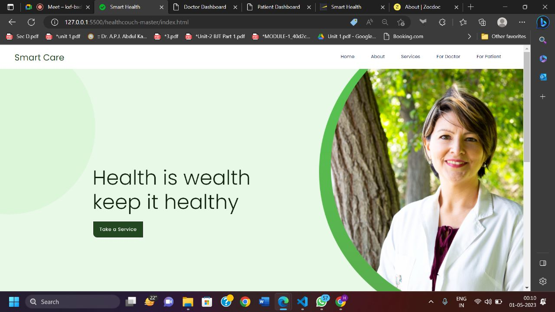

**Figure 1: Showing the Home Page**

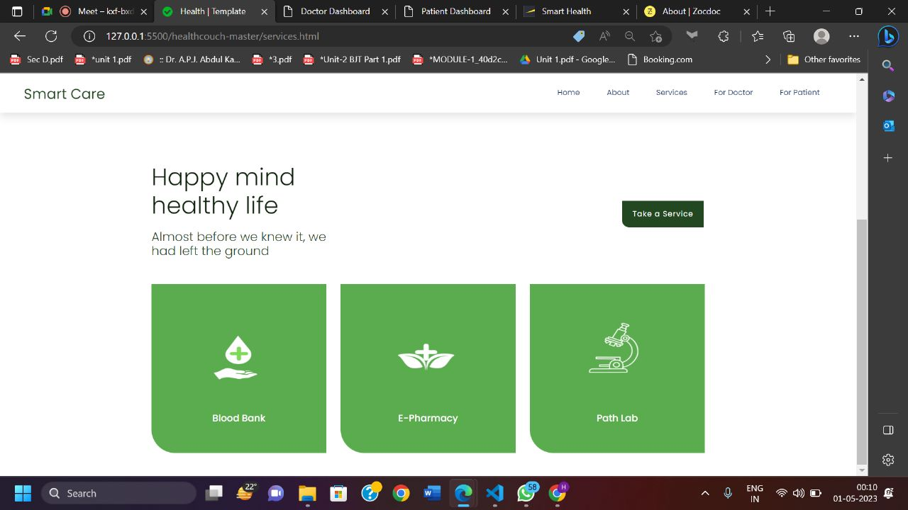

**Figure 2: Showing the Services section**

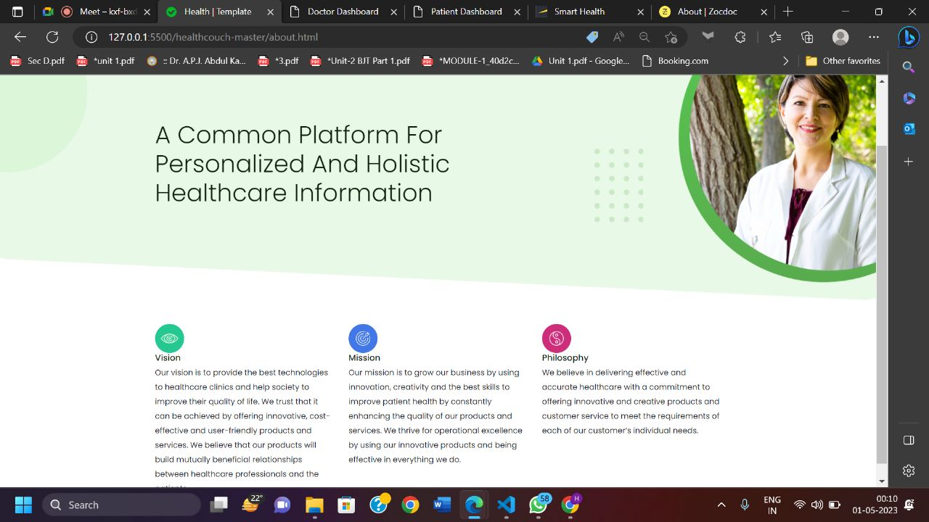

**Figure 3: Showing the About section**

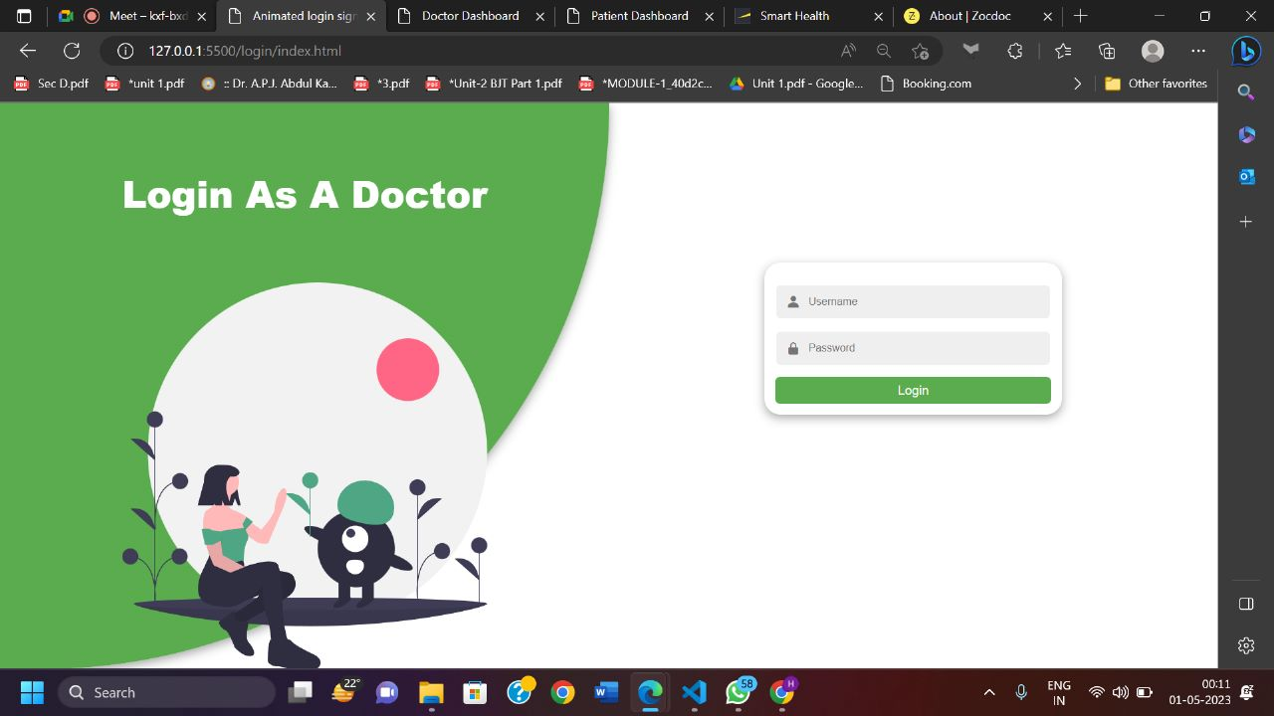

**Figure 4: Showing the Login Page for Doctor**

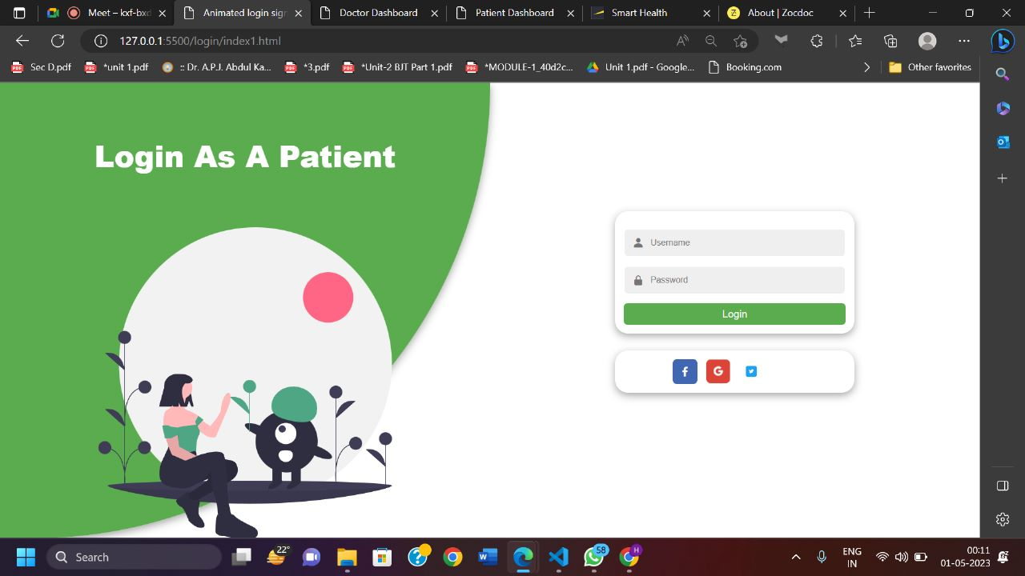

**Figure 5: Showing the Login Page for Patient**

**3.2 Hardware Interfaces**

Even though this architecture is hardware- software integrated web architecture, we will not be designing any specific hardware interfaces to run the system. Our system is a web-based system, so we will be launching it in several computers online. Smart care projects may integrate with EHR systems to provide healthcare professionals with access to patient data. These systems can be connected to the web-based platform via APIs.

1. **System Features**
   1. **System Features 1**

The features of Smart Care web based project is -

**Access the website -** the access of our website is not restricted to registered users only. Someone who is not registered can also see the basic functionalities what the website is serving for.

**Constantly update and modifying government’s health policy -** The website will provide the service to access other official government websites. So that users of the website will be up-to-date, in respect to the policies which are mentioned on government website.

**User Registration and login -** A user, must be able to register their credentials. They should provide their basic functionalities about themselves eg. Name, address, email, phone number. They should also identify themselves the kind of users , that can be patient or doctor.

**Electronic Health Records -** This is a digital version of a patient’s medical records allow to access and update patient records in real-time, facilitating collaboration between the doctors and the patients.

**Telemedicine -** This feature allows the patient to buy the medicine online form the registered government websites. This feature helps the user to buy the medicines in low prices as compared to all other private medicines shop.

**Online Blood bank -** This features allows the patient to see the blood donors availability according to the blood group. This is also the registered and approved government website which will provide the filtered data so that the relevant information of the acceptor and donor is displayed.

**Online Path Labs -** This feature allows the patient to access the government official website for appointing the test in pathology labs. This is also the home service provided by the government to the patients.

**Doctor’ Dashboard -** Doctor’s Dashboard allows doctor’s to access the appointed patient’s only. Doctor can see their past records also such as medical records, test results and past prescriptions (from other doctor). As doctor has to provide the electronic prescriptions, which reduces the risk of errors and making it easier for patients to refill their prescriptions. Dashboard also consists of many other options such as other doctors where the list of registered doctors are made visible. It also consists of Hospitals option which consists of all those hospitals which are associated to the particular doctor.

**5. Other Nonfunctional Requirements**

**5.1 Performance Requirements**

To determine the performance requirements of Smart Health website, several factors should be considered, including:

1. **Response Time –** It is expected to have a high response time when the user of the system across different functions in the system.
2. **Capacity –** It is expected to store all records of the registered users in its database.
3. **User Interfaces –** It is expected to have high response time to be able to meet deadlines.
4. **Conformity –**  The system must conform to the Microsoft Accessibility.
5. **Concurrent users:** The number of users accessing the website simultaneously will affect the website's performance. The website should be able to handle multiple users and conversions simultaneously without any delays or errors.
6. **Processing speed –** The speed at which the website can convert the files is crucial to its performance. The website should be able to process the files quickly and efficiently, without causing any delays or timeouts.
7. **Network bandwidth –** The speed of the website's network connection will affect the performance of the website. A faster connection will allow for faster file transfers and conversions.
8. **Security –** The website should be designed to handle data securely and protect user data from unauthorized access.
9. **Error handling –** The website should be able to handle errors and exceptions gracefully, without crashing or causing data loss.

**5.2 Safety Requirements**

All the administrative and data entry operators have unique logins, so the website can understand who is logging in to the system and makes sure no intruder is allowed except system administrative. Therefore nobody can change record and valuable data.

**5.3 Security Requirements**

1. **Access control:** The system must have access control measures in place to ensure that only authorized users can access the system and its data. This includes authentication mechanisms, such as passwords or multi-factor authentication, and authorization mechanisms, such as role-based access control.
2. **Data protection:** The system must implement adequate data protection measures, such as encryption and data backup, to prevent data breaches, loss, or corruption.
3. **Secure communication:** The system must use secure communication protocols, such as HTTPS or SSL/TLS, to protect data in transition.
4. **Physical security:** The system must implement physical security measures, such as access controls, surveillance, and backup power, to protect the physical infrastructure that hosts the software and data.

**5.4 Software Quality Attributes**

1. **Availability –** The system shall be available all the time.
2. **Correctness –** Bug-free software which fulfils the correct requirements of the client.
3. **Usability –** Software can be used again and again without distortion.
4. **Accessibility –** Administrator and many other users can access the system but the access level is controlled for each user according to their work scope.
5. **Accuracy –** The reliability on the information/ output. Can depend – on sure of the outcome.
6. **Stability –** The system output won’t change time to time. Same output will be given always for a given input.

**APPENDIX A Glossary**

Here are some terms and definitions that may be useful for an SRS (Software Requirements Specification) for a Smart Care web-based project:

1. **Smart care:** The name of the web-based project that is being developed.
2. **SRS:** Software Requirements Specification, a document that outlines the requirements for a software project.
3. **User:** A person who interacts with the Smart Care website.
4. **Patient:** A person who receives healthcare services through the Smart Care.
5. **Electronic health record (EHR):** A digital record of a patient's medical history, including diagnoses, treatments, and other relevant information.
6. **Telehealth:** The use of telecommunications technology to provide healthcare services remotely.
7. **Prescription management:** The process of managing prescriptions and medications for patients.
8. **Security:** The measures taken to protect the confidentiality, integrity, and availability of the Smart Care website and its data.
9. **Integration:** The seamless combination of different features and functionalities within the web application.
10. **API:** An Application Programming Interface is a set of protocols and tools for building software applications that define how different software components should interact with each other.

**APPENDIX B Analysis Models**

**Use Case Diagram:**

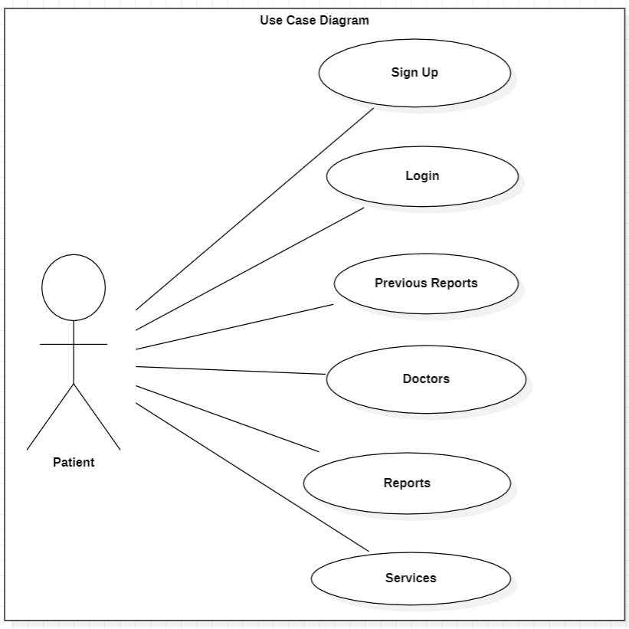

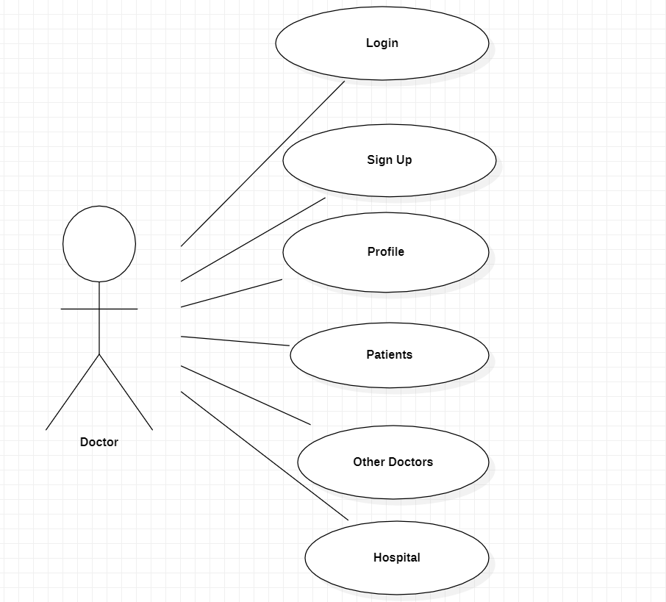

**Data Flow Diagram:**

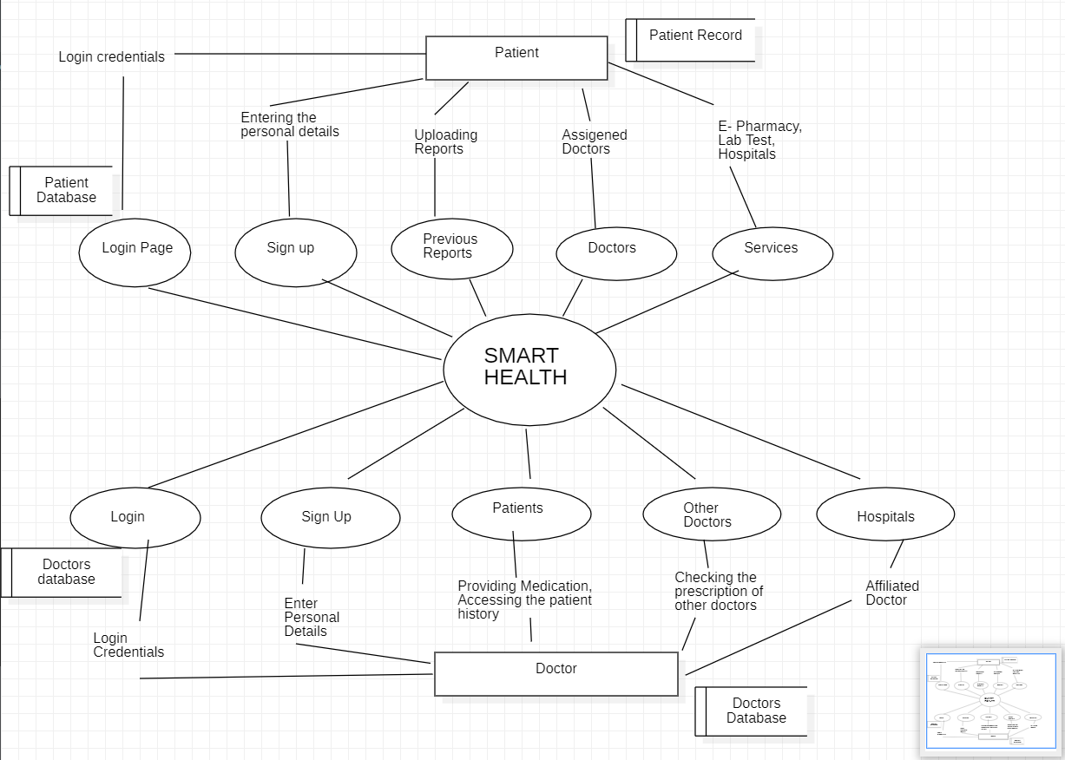

**Sequence Diagram:**

* **Patient Login**

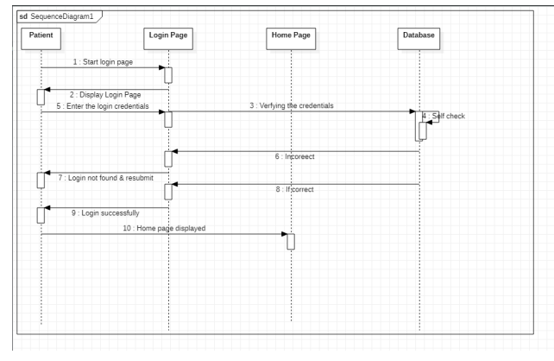

* **Doctor Login**

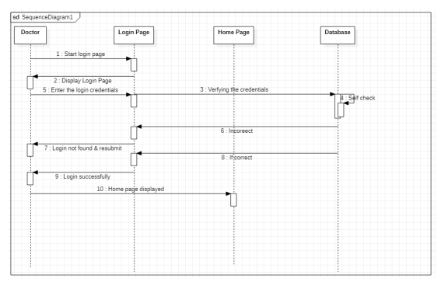

* **Patient wants to upload their document**

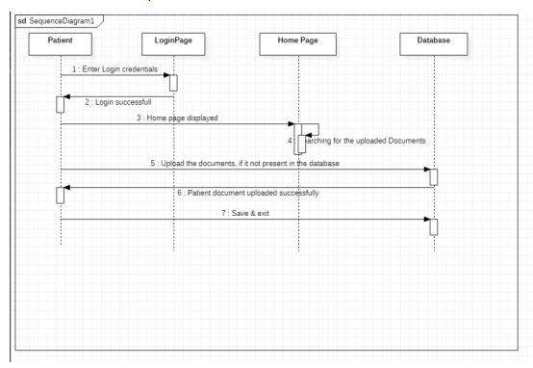

* **Doctor accessing the previous records of patient and also providing the treatment for their disease.**

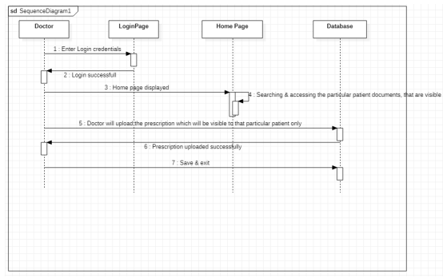

**Class Diagram:**

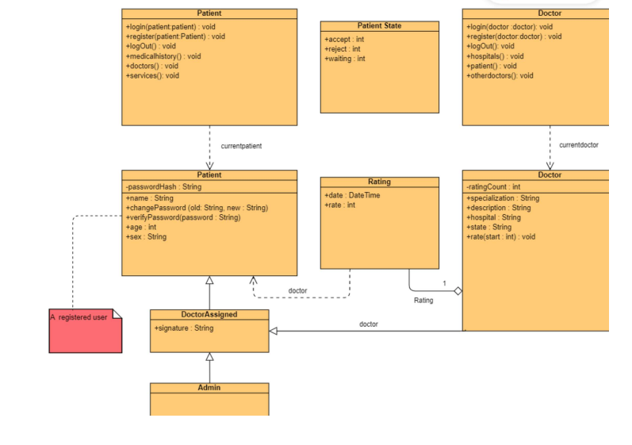

**APPENDIX C To Be Determined List**

1. **Integration:** The seamless combination of different features and functionalities within the web application.
2. **Response time:** The time it takes for the web application to respond to user actions, typically within 2-3 seconds.

1. **API:** An Application Programming Interface is a set of protocols and tools for building software applications that define how different software components should interact with each other.